

**Green University of Bangladesh**

**Department of Computer Science and Engineering(CSE)**

**Faculty of Sciences and Engineering**

**Semester: (Spring , Year:2024), B.Sc. in CSE (Day)**

**LAB REPORT NO #02**

**Course Title: Computer Networking Lab**

**Course Code: CSE - 312 Section: 213_D5**

**Lab Experiment Name: Configuration of Static and Dynamic Routing Protocols.**

**Student Details**

| **Name** | | **ID** |
| --- | --- | --- |
|  | **MD Dulal Hossain** | **213902116** |

**Lab Date** **: 23– 03 - 2024**

**Submission Date** **: 30– 03 - 2024**

**Course Teacher’s Name : MS. Rusmita Halim Chaity**

**[For Teachers use only: Don’t Write Anything inside this box]**

| **Lab Report Status**  **Marks: ………………………………… Signature:.....................**  **Comments:.............................................. Date:..............................** |
| --- |

**1. TITLE OF THE LAB EXPERIMENT**

In the previous task, messages are transferred to only three networks. In the given task, there are 4 different networks. The networks are interconnected by five routers. The routers are interconnected by serial ports. Then configure the static routes from the router config mode.

**2. OBJECTIVES/AIM**

* To understand the static and dynamic routing.
* Configure static routes on each router to allow communication between all clients.
* Configure dynamic routes on each router to allow communication between all clients.

**3. PROCEDURE / ANALYSIS / DESIGN**

1. Create a network topology by setting up all the necessary devices in Cisco Packet Tracer.
2. Configure static IP addresses on the PC, and other devices.
3. Configure the Fast Ethernet and Serial interfaces of all the Router.
4. For static routing, enable the static protocol from the router configuration mode. Then set the destination network address, subnet mask and next hop for all the network.
5. For dynamic routing, enable the RIP routing protocol from the router configuration mode. Then, add all the required network addresses for all of the routers.

**4. IMPLEMENTATION**

**4.1 IP Configuration**

Configure static IP addresses on the PC,Router and server.

Click the device and go to the Desktop tab > IP Configuration.

1. For PC 1: Set 172.16.0.2 as IP address , 255.255.0.0 as Subnet Mask & Gateway is 172.16.0.1 (Figure 1).

2. For PC 2: Set 172.17.0.2 as IP address , 255.255.0.0 as Subnet Mask & Gateway is 172.17.0.1

3. For PC 3: Set 172.18.0.2 as IP address , 255.255.0.0 as Subnet Mask & Gateway is 172.18.0.1

4. For PC 4: Set 172.19.0.2 as IP address , 255.255.0.0 as Subnet Mask & Gateway is 172.19.0.1

5. For Server 1 : Set 172.16.0.1 as IP address , 255.255.0.0 as Subnet Mask & Gateway is 172.16.0.1 (Figure 2).

6. For Server 2: Set 172.17.0.1 as IP address , 255.255.0.0 as Subnet Mask & Gateway is 172.17.0.1

7. For Server 3: Set 172.18.0.1 as IP address , 255.255.0.0 as Subnet Mask & Gateway is 172.18.0.1

8. For Server 4: Set 172.19.0.1 as IP address , 255.255.0.0 as Subnet Mask & Gateway is 172.19.0.1

9. For Router 0/0 :

1. First Ethernet set 172.16.0.1 as IP address and 255.255.0.0 as Subnet Mask (Figure 3).
2. For serial 0/0/0: Set 11.0.0.1 as IP address and 255.0.0.0 as Subnet Mask (Figure 4).
3. For serial 0/0/1: Set 12.0.0.1 as IP address and 255.0.0.0 as Subnet Mask (Figure 5).

10. For Router 0/1 :

1. First Ethernet set 172.17.0.1 as IP address and 255.255.0.0 as Subnet Mask .
2. For serial 0/1/0: Set 13.0.0.1 as IP address and 255.0.0.0 as Subnet Mask.
3. For serial 0/0/1: Set 12.0.0.2 as IP address and 255.0.0.0 as Subnet Mask.

11. For Router 0/2 :

1. First Ethernet set 172.18.0.1 as IP address and 255.255.0.0 as Subnet Mask .
2. For serial 0/2/0: Set 14.0.0.1 as IP address and 255.0.0.0 as Subnet Mask.
3. For serial 0/2/1: Set 16.0.0.1 as IP address and 255.0.0.0 as Subnet Mask.

12. For Router 0/3 :

1. First Ethernet set 172.19.0.1 as IP address and 255.255.0.0 as Subnet Mask .
2. For serial 0/3/0: Set 16.0.0.2 as IP address and 255.0.0.0 as Subnet Mask.
3. For serial 0/2/1: Set 15.0.0.2 as IP address and 255.0.0.0 as Subnet Mask.

13. For Router 0 :

1. For serial 0/0/0: Set 11.0.0.2 as IP address and 255.0.0.0 as Subnet Mask.
2. For serial 0/1/0: Set 13.0.0.2 as IP address and 255.0.0.0 as Subnet Mask.
3. For serial 0/2/0: Set 14.0.0.2 as IP address and 255.0.0.0 as Subnet Mask.
4. For serial 0/3/0: Set 15.0.0.2 as IP address and 255.0.0.0 as Subnet Mask.

| Figure 1 : IP configure PC 1 | Figure 2 : IP configure for Server 1. |
| --- | --- |

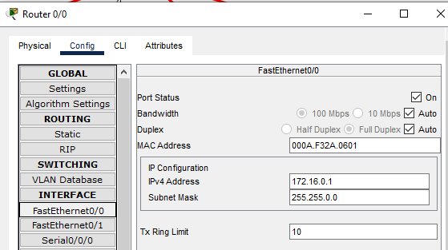

Figure 3 : IP configureFastEthernet0/0.

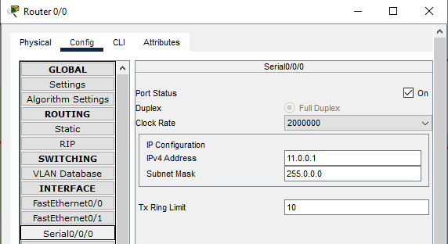

Figure 4 : IP configure Serial 0/0/0.

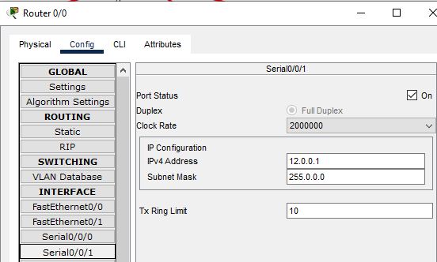

Figure 5 : IP configure Serial 0/0/1 .

**4.2 Routing**

**Dynamic or RIP :**

For Router 0/0 , 0/1 , 0/2 , 0/3 and 0 . All the router add all the network address like 11.0.0.0 , 12.0.0.0 ,13.0.0.0 ,14.0.0.0 ,15.0.0.0 ,16.0.0.0 , 172.16.0.0 , 172.17.0.0 , 172.18.0.0 and 172.19.0.0 (Figure 6).

**Static :**

For Router 0/0 172.17.0.0 via 12.0.0.2 , 172.18.0.0 via 14.0.0.1 and 172.19.0.0 via 15.0.0.1 (Figure 7).

For others router 0/1 , 0/2 , 0/3 and 0 connect same way . (Figure 7).

| Figure 6 : Dynamic or RIP Routing. | Figure 7 : Static Routing. |
| --- | --- |

**5. TEST RESULT / OUTPUT**

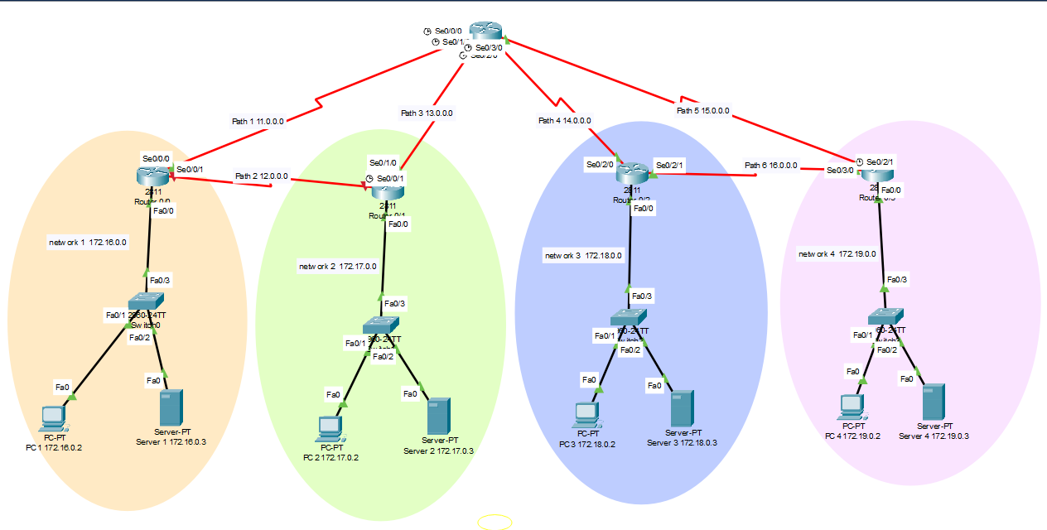

Figure 8 : A network Check Static & Dynamic Routing Protocols.

**5.1 Static Test**

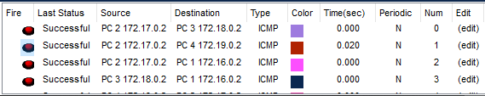

Figure 9 : Static all mail sent successfully.

**5.2 Dynamic or RIP Test**

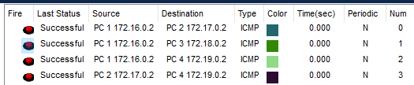

Figure 10 : Dynamic or RIP all mail sent successfully.

**6. ANALYSIS AND DISCUSSION**

With a focused objective on understanding static and dynamic routing configurations, we aim to grasp the process of directing packets from one device to another across networks. This task involves configuring both static and dynamic routes to facilitate packet transmission between devices. Engaging in additional lab exercises enhances our confidence in achieving these objectives effectively, ensuring competence in routing procedures. So we say that our lab report work 100% properly.